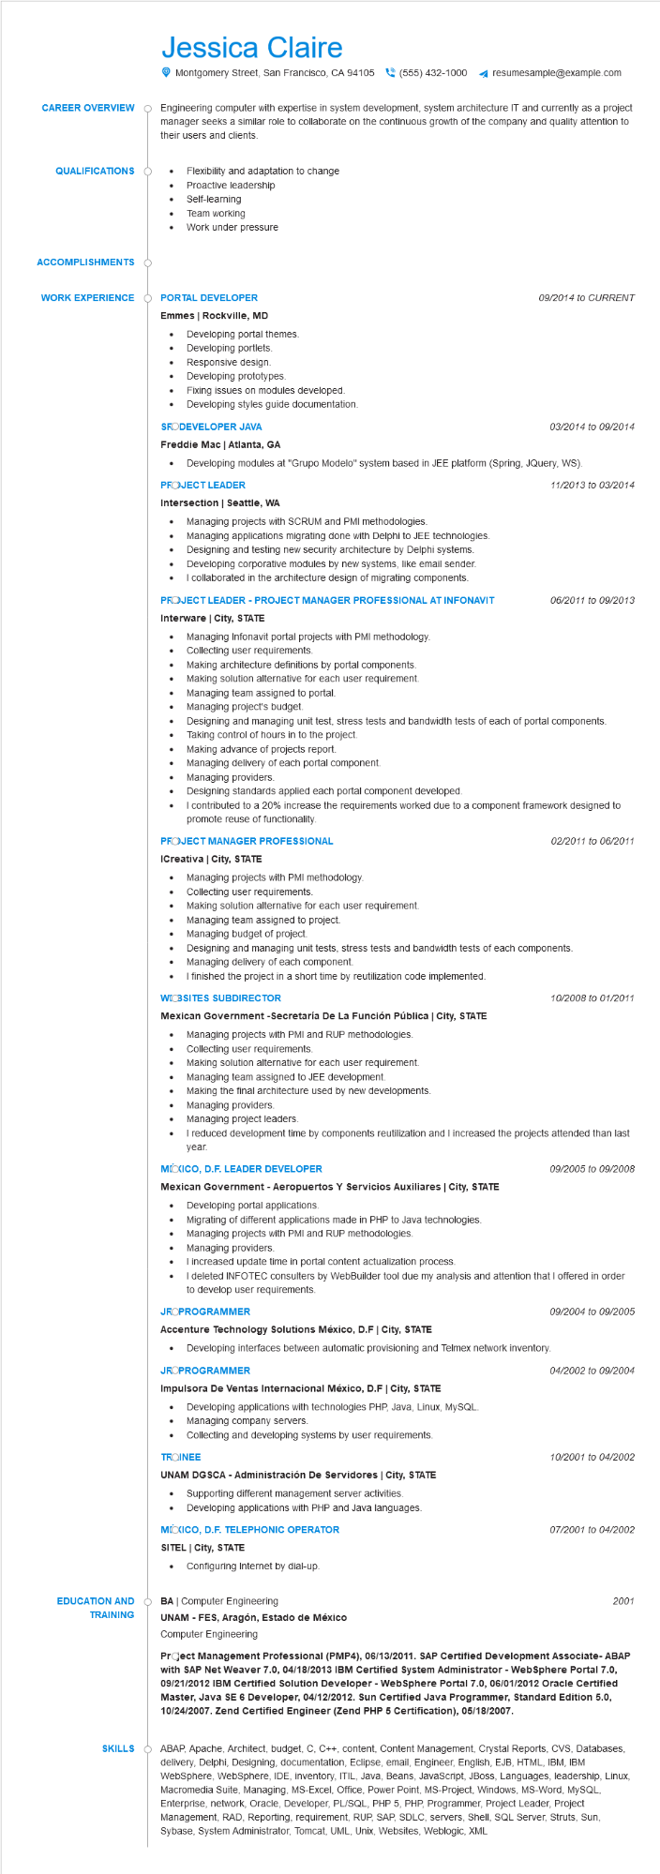
Jessica Claire
Montgomery Street, San Francisco, CA 94105(555) 432-1000
resumesample@example.com
CAREER OVERVIEW Q Engineering computer with expertise in system development, system architecture IT and currently as a project manager seeks a similar role to collaborate on the continuous growth of the company and quality attention to their users and clients.
QUALIFICATIONS
•
Flexibility and adaptation to change
ACCOMPLISHMENTS
•
Proactive leadership
Self-learning
Team working
• Work under pressure
WORK EXPERIENCE O PORTAL DEVELOPER
Emmes | Rockville, MD
EDUCATION AND
TRAINING
Developing portal themes.
.
Developing portlets.
Responsive design.
Developing prototypes.
·
Fixing issues on modules developed.
•
Developing styles guide documentation.
SRODEVELOPER JAVA
Freddie Mac | Atlanta, GA
09/2014 to CURRENT
03/2014 to 09/2014
· Developing modules at "Grupo Modelo" system based in JEE platform (Spring, JQuery, WS).
PROJECT LEADER
11/2013 to 03/2014
Intersection | Seattle, WA
•
• Managing projects with SCRUM and PMI methodologies.
• Designing and testing new security architecture by Delphi systems.
Managing applications migrating done with Delphi to JEE technologies.
•
Developing corporative modules by new systems, like email sender.
•
I collaborated in the architecture design of migrating components. PROJECT LEADER - PROJECT MANAGER PROFESSIONAL AT INFONAVIT Interware | City, STATE
06/2011 to 09/2013
Managing Infonavit portal projects with PMI methodology. Collecting user requirements.
•
Making architecture definitions by portal components.
•
Making solution alternative for each user requirement.
•
Managing team assigned to portal.
Managing project's budget.
Designing and managing unit test, stress tests and bandwidth tests of each of portal components.
Taking control of hours in to the project.
Making advance of projects report.
Managing delivery of each portal component.
Managing providers.
•
Designing standards applied each portal component developed.
I contributed to a 20% increase the requirements worked due to a component framework designed to promote reuse of functionality.
PROJECT MANAGER PROFESSIONAL
ICreativa | City, STATE
Managing projects with PMI methodology.
Collecting user requirements.
Making solution alternative for each user requirement.
02/2011 to 06/2011
•
Managing team assigned to project.
Managing budget of project.
Designing and managing unit tests, stress tests and bandwidth tests of each components.
Managing delivery of each component.
• I finished the project in a short time by reutilization code implemented.
WICBSITES SUBDIRECTOR
10/2008 to 01/2011
Mexican Government -Secretaría De La Función Pública | City, STATE
• Managing projects with PMI and RUP methodologies.
Collecting user requirements.
•
Making solution alternative for each user requirement.
Managing team assigned to JEE development.
Making the final architecture used by new developments.
• Managing providers.
•
Managing project leaders.
I reduced development time by components reutilization and I increased the projects attended than last year.
MOXICO, D.F. LEADER DEVELOPER
Mexican Government - Aeropuertos Y Servicios Auxiliares | City, STATE
· Developing portal applications.
Migrating of different applications made in PHP to Java technologies.
Managing projects with PMI and RUP methodologies.
09/2005 to 09/2008
•
Managing providers.
I increased update time in portal content actualization process.
•
I deleted INFOTEC consulters by WebBuilder tool due my analysis and attention that I offered in order to develop user requirements.
JROPROGRAMMER
Accenture Technology Solutions México, D.F | City, STATE
• Developing interfaces between automatic provisioning and Telmex network inventory.
JROPROGRAMMER
Impulsora De Ventas Internacional México, D.F | City, STATE
09/2004 to 09/2005
04/2002 to 09/2004
• Developing applications with technologies PHP, Java, Linux, MySQL.
• Managing company servers.
•
Collecting and developing systems by user requirements.
TROINEE
UNAM DGSCA - Administración De Servidores | City, STATE
• Supporting different management server activities. Developing applications with PHP and Java languages.
MÉXICO, D.F. TELEPHONIC OPERATOR
SITEL City, STATE
Configuring Internet by dial-up.
BA | Computer Engineering
UNAM - FES, Aragón, Estado de México
Computer Engineering
10/2001 to 04/2002
07/2001 to 04/2002
2001
Project Management Professional (PMP4), 06/13/2011. SAP Certified Development Associate- ABAP with SAP Net Weaver 7.0, 04/18/2013 IBM Certified System Administrator - WebSphere Portal 7.0, 09/21/2012 IBM Certified Solution Developer - WebSphere Portal 7.0, 06/01/2012 Oracle Certified Master, Java SE 6 Developer, 04/12/2012. Sun Certified Java Programmer, Standard Edition 5.0, 10/24/2007. Zend Certified Engineer (Zend PHP 5 Certification), 05/18/2007.
SKILLS ABAP, Apache, Architect, budget, C, C++, content, Content Management, Crystal Reports, CVS, Databases, delivery, Delphi, Designing, documentation, Eclipse, email, Engineer, English, EJB, HTML, IBM, IBM WebSphere, WebSphere, IDE, inventory, ITIL, Java, Beans, JavaScript, JBoss, Languages, leadership, Linux, Macromedia Suite, Managing, MS-Excel, Office, Power Point, MS-Project, Windows, MS-Word, MySQL, Enterprise, network, Oracle, Developer, PL/SQL, PHP 5, PHP, Programmer, Project Leader, Project Management, RAD, Reporting, requirement, RUP, SAP, SDLC, servers, Shell, SQL Server, Struts, Sun, Sybase, System Administrator, Tomcat, UML, Unix, Websites, Weblogic, XML

